**Binary Search Algorithm**

**What is Search?**

Search is a process of finding a value in a list of values. In other words, searching is the process of locating given value position in a list of values.

**Binary Search Algorithm**

Binary search algorithm finds given element in a list of elements with **O(log n)** time complexity

where **n** is total number of elements in the list. The binary search algorithm can be used with only sorted list of element. That means, binary search can be used only with lkist of element which are already arraged in a order. The binary search can not be used for list of element which are in random order. This search process starts comparing of the search element with the middle element in the list. If both are matched, then the result is "element found". Otherwise, we check whether the search element is smaller or larger than the middle element in the list. If the search element is smaller, then we repeat the same process for left sublist of the middle element. If the search element is larger, then we repeat the same process for right sublist of the middle element. We repeat this process until we find the search element in the list or until we left with a sublist of only one element. And if that element also doesn't match with the search element, then the result is "Element not found in the list".

Binary search is implemented using following steps...

**Step 1:** Read the search element from the user

**Step 2:** Find the middle element in the sorted list

**Step 3:** Compare, the search element with the middle element in the sorted list.

**Step 4:** If both are matching, then display "Given element found!!!" and terminate the function

**Step 5:** If both are not matching, then check whether the search element is smaller or larger than

middle element.

**Step 6:** If the search element is smaller than middle element, then repeat steps 2, 3, 4 and 5 for

the left sublist of the middle element.

**Step 7:** If the search element is larger than middle element, then repeat steps 2, 3, 4 and 5 for

the right sublist of the middle element.

**Step 8:** Repeat the same process until we find the search element in the list or until sublist

contains only one element.

**Step 9:** If that element also doesn't match with the search element, then display "Element not

found in the list!!!" and terminate the function.

**Example**

Consider the following list of element and search element...

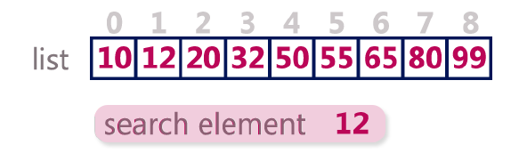

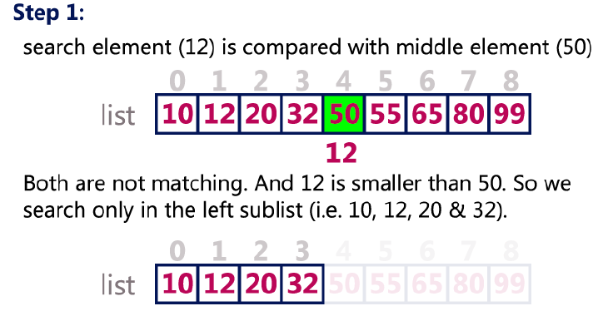

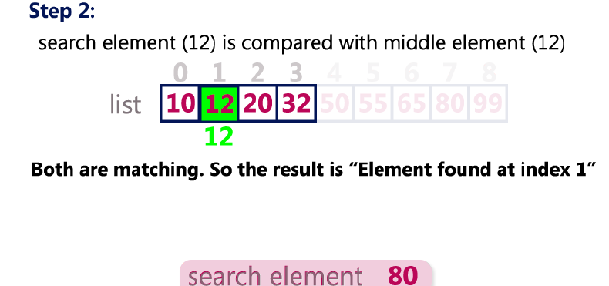

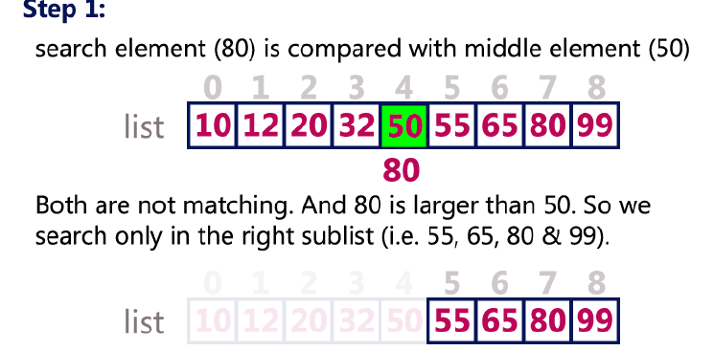

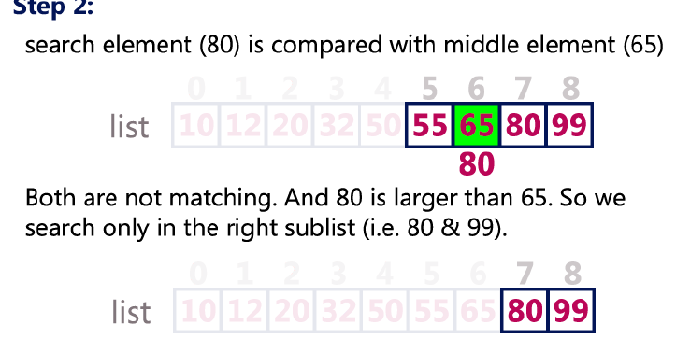

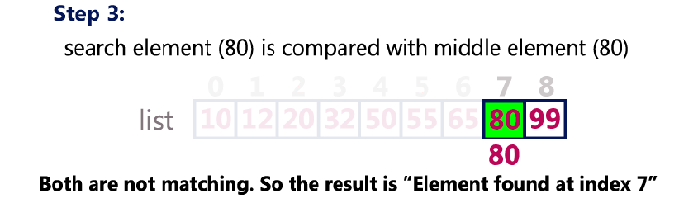

**Binary Search Program in C Programming Language**

**#include<stdio.h>**

**#include<conio.h>**

**void main()**

**{**

**int first, last, middle, size, i, sElement, list[100];**

**clrscr();**

**printf("Enter the size of the list: ");**

**scanf("%d",&size);**

**printf("Enter %d integer values in Assending order\n", size);**

**for (i = 0; i < size; i++)**

**scanf("%d",&list[i]);**

**printf("Enter value to be search: ");**

**scanf("%d", &sElement);**

**first = 0;**

**last = size - 1;**

**middle = (first+last)/2;**

**while (first <= last) {**

**if (list[middle] < sElement)**

**first = middle + 1;**

**else if (list[middle] == sElement) {**

**printf("Element found at index %d.\n",middle);**

**break;**

**}**

**else**

**last = middle - 1;**

**middle = (first + last)/2;**

**}**

**if (first > last)**

**printf("Element Not found in the list.");**

**getch();**

**}**